**SHOP MANAGEMENT SYSTEM**

**ARRAFI AHSAN SOMUDRO**

**Contents:**

1. Introduction……………………………………………………………3
2. Project Proposal……………………………………………………….3
3. Diagram
   1. Class Diagram………………………………………………….4-5
   2. Use Case Diagram……………………………………………...6
   3. Activity Diagram……………………………………………….7
4. User Interface………………………………………………………….8-9
5. Scenario Description………………………………………………….10
6. ER Diagram…………………………………………………………....11
7. Normalization………………………………………………………….12-23
8. Schema Diagram……………………………………………………….24
9. Table Creation…………………………………………………………25-28
10. Data insertion………………………………………………………....28-37
11. Query writing
    1. SQL…………………………………………………………….38-42
    2. PL/SQL………………………………………………………….43-59

12.Conclusion …………………………………………………………….60

**1. Introduction:**

E-Commerce websites are online portals that facilitate online transactions of goods and services through means of the transfer of information and funds over the Internet. We all know the importance of e-commerce, especially in this pandemic situation. There are lots of e-commerce websites available such as Amazon, Daraz, E-valy and many more. But to handle the data of this type of giant e-commerce websites it is required to build a well-structured database system. A database system helps e-commerce sites pinpoint potential customers based on compiled information. Marketing teams can use customer data that is stored within the database to create targeted lists that will be used for directing marketing efforts. The more information a marketing team has, the better they can identify and tailor communications with them. Not only will this method help to retain customers, but also helps to gain new customers as well. The database also stores the information of employees and other stuffs of the company. In this modern era, we cannot even think any website or software working without a database. In this project we will build a database management system that will represent any other e-commerce websites currently available in the market.

**2. Project Proposal:**

Our goal is to develop a standard database management system for an e-commerce website that can handle all the functionalities related to database. With this system we will be able to manage the database according to the need of the company. We will be able to handle the data of new customers registered to website, order of customers, data related to each order like delivery status, delivery time, delivery completion etc. We can also manage the data of employees and stuffs of the company such as details of employees, departments, accounts, and many more. Our project will help the authority to generate any report regarding profits, marketing, performance of employees, customer involvements, warehouse availabilities etc. A brief description of our database system is given in the scenario description section.

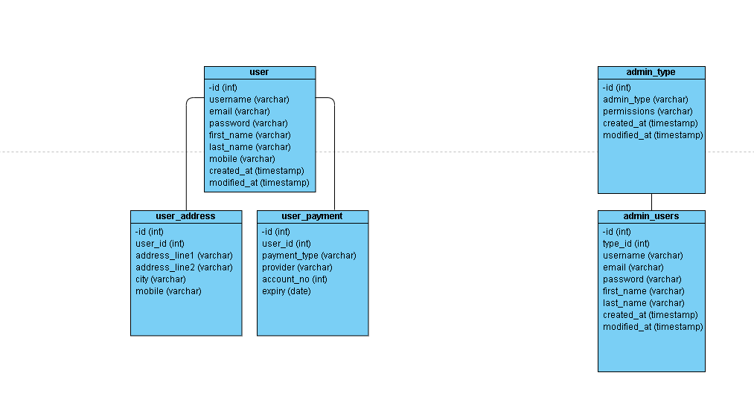**3. Diagram  
  
a) Class Diagram:**

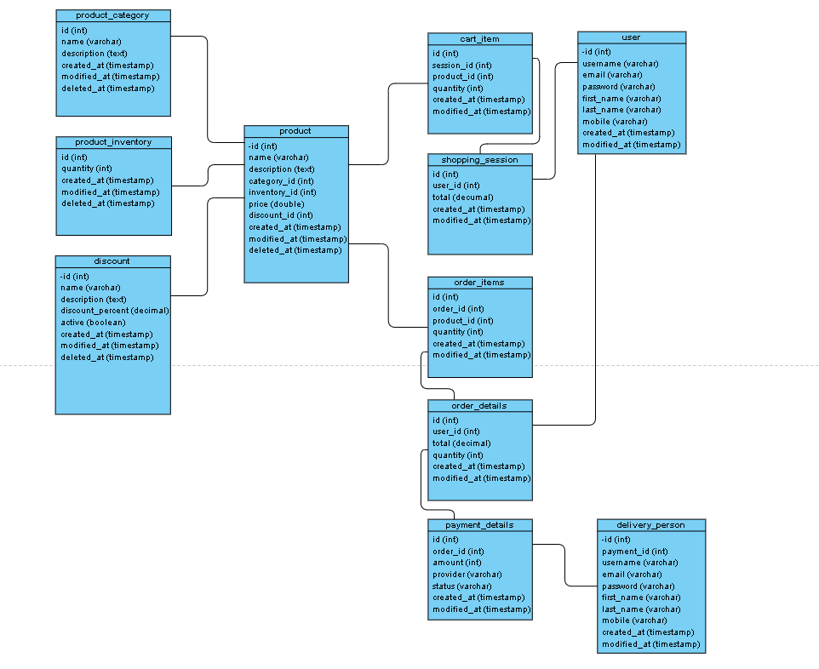

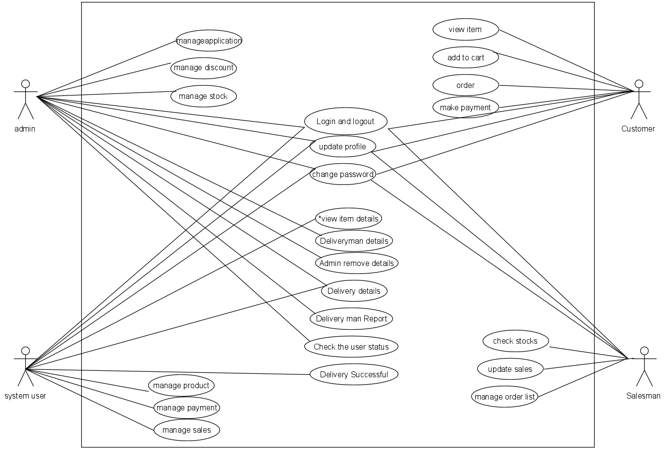b) **Use case Diagram:** This use case diagram there are four actor Admin, System user, Customer, Salesman.

**C) Activity Diagram:**

This is activity diagram of shop management system which shows the flow between the activity of sales, stock inventory, payments, discounts, product. The main activity involved in this UMI Activity Diagram of shop management system are as follows:

1. Sales Activity  
2.Stock Inventory Activity  
3.Payments Activity  
4.Discount Activity  
5.Product Activity

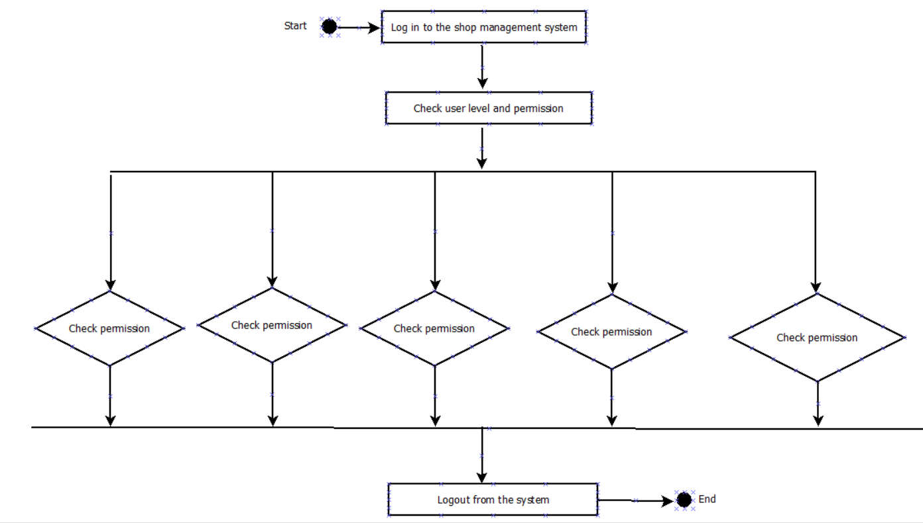  
**Feature Of the Activity UML Diagram Of shop management system**   
1. Admin user can search sales, view description of a selected sales, add sales, update sales and delete sales  
2. It shows the activity flow of editing, adding and updating of stock inventory  
3. User will be able to search and generate report of payments, Discounts, product  
4. All objects such as (sales, stock inventory, product) are interlinked  
5. Its show the full description and flow of sales, Discounts, product, payments, stock inventory

**Login Activity Diagram Of shop management system:**   
  
This is the Login Activity diagram of shop management system, which shows the flows of Login activity, where admin will be able to login using their username and password. After login user can manage all the operation on payments, sales, stock inventory, product, Discounts. All the pages such as stock inventory, product, Discounts are secure and user can access these pages after login. The diagram bellow helps demonstrate how the login page works in a shop management system. The various objects in the product, payments, sales, stock inventory and discount page-intact over the course of activity and user will not be able to access this page without verifying their identity

**4.User Interface**: Here we give two user interface login and registration

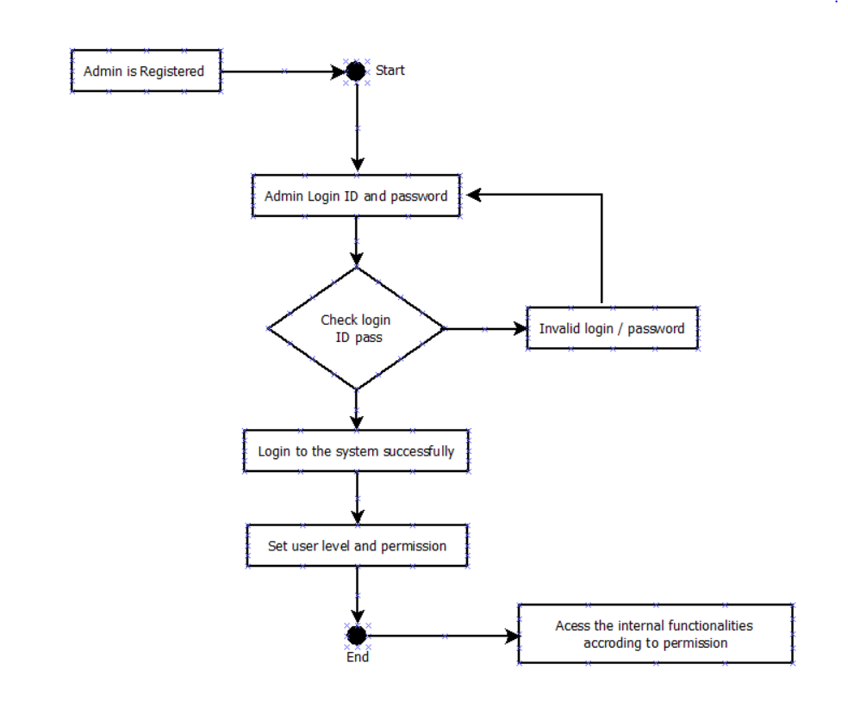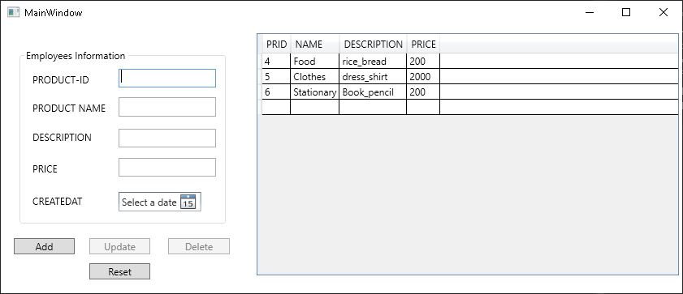

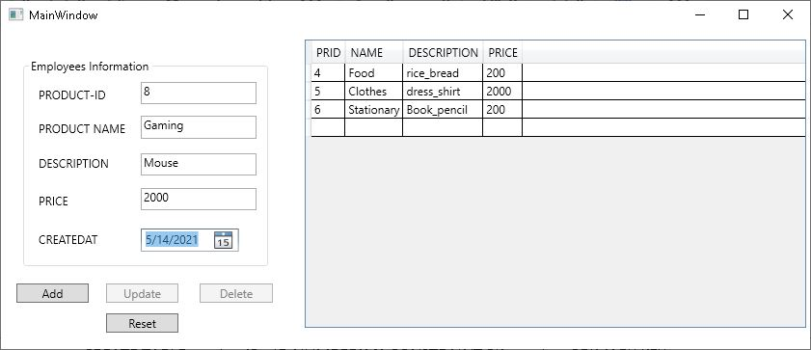

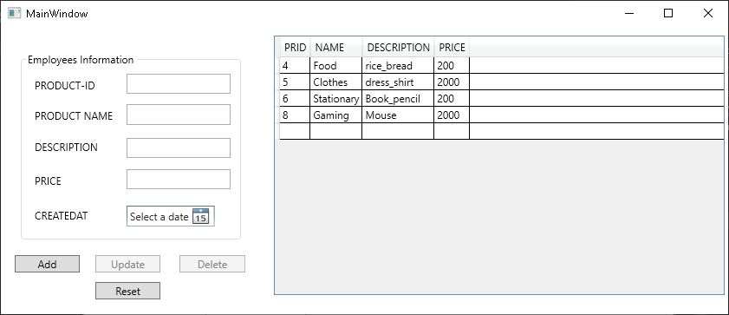

5. **Scenario Description:**

This scenario description is about shop management system. We have many type of entities, multiple relationships among them and show all the visual instrument of database table and relations between customers,sells, product etc.The main entities of the shop management system are product,customer,Admin,payment,order,delivery.There is an one admin who can grant all the permission.Admin has type where type has lots of attributes like id,username,email,password,fast_name,last_name,last_name,created_at,modified_at.A lots of/many user create many shopping session here shopping session has attributes like id, total modify_at and create_at.One and many user can selected many product,product have an unique id,name,price,create_at,modified_at,delete_at, description and drop them in the cart.Product have a category.One product have one category.Category has been created_at,modified_at,deleted_at and also category have unique id,name.When one user selected many product and this was store his/her own cart.One user has One cart but Many product has store one cart.Here cart has id,quantity,create_at,modify_at. All the order details will be store in the database.Then user can get discount if there any discount is available.This discount has many product.Here discount have unique id,name,percent. After selecting all the product One user can confirm many order items.Order items have id,quantity,create_at,modify_at and User make payment like online mobile banking,Card etc.This payment details will be stored in database.One user pay their payment many payment methood.When make payment this time payment method created and also modified.Each payment have unique transaction id .After the payment the delivery man will be delivering the product to the user.Here delivery person details like first_name,last_name,email,username,unique id store in database.Many product deliver One and many delivery man.

**6. ER Diagram:**

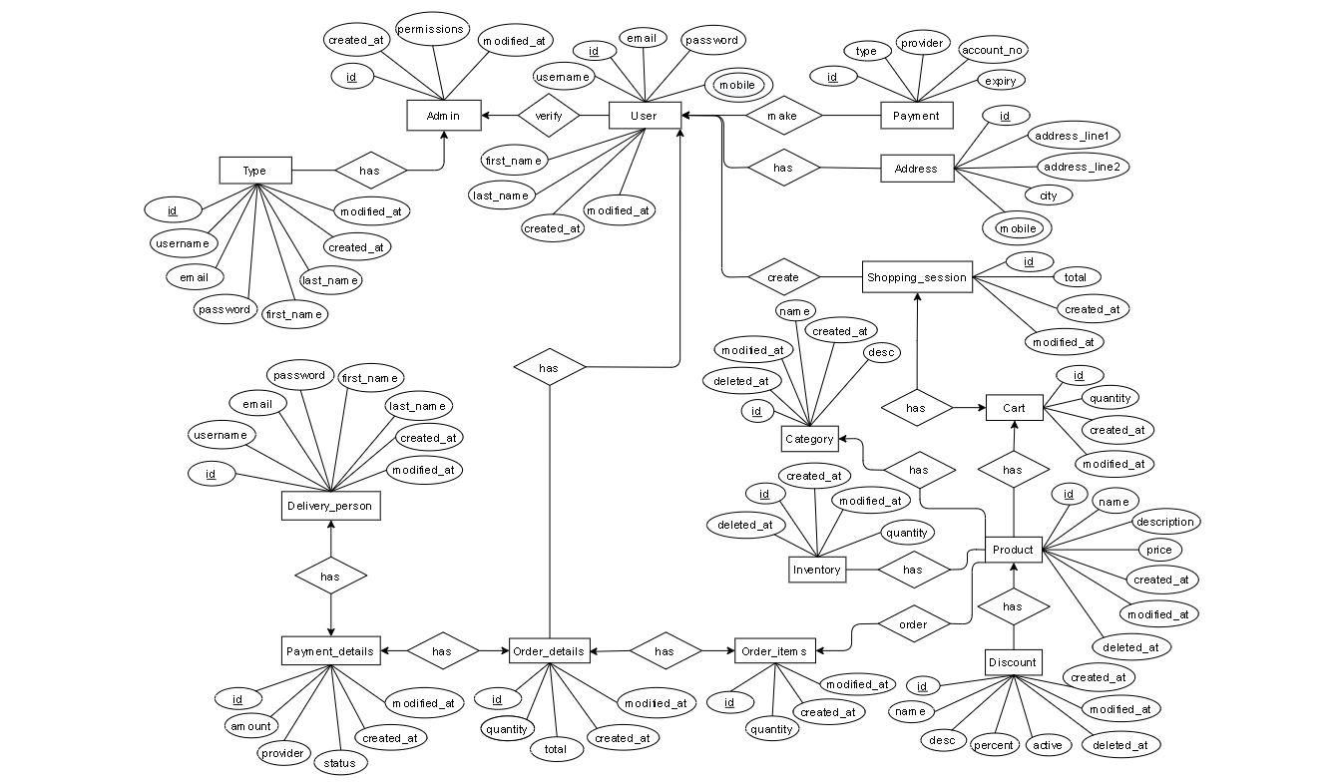

**7. Normalization:**

Has(T_id , username , email, password , first_name , Last_name , T_created_at , T_modified_at , A_id , A_created_at , T_modified_at , permissions)

1NF: no multivalued available

2NF:

T_id , username , email, password , first_name , Last_name , T_created_at , T_modified_at

A_id , A_created_at , T_modified_at , permissions

Relationship one to many

T_id , username , email, password , first_name , Last_name , T_created_at , T_modified_at

A_id , A_created_at , T_modified_at , permissions

TA_id , T_id , A_id

3NF : No transitive dependency available

Total table

1.**T_id** (primary key), username , email, password , first_name , Last_name , T_created_at , T_modified_at

2. **A_id** (primary key) , A_created_at , T_modified_at , permissions

3.**TA_id** (primary key), **T_id** (foreign key) , **A_id** (foreign key)

Has(D_id , username , email, password, first_name , Last_name , D_created_at , D_modified_at , Pa_id , amount , provider , status , P_created_at , P_modified_at)

1NF : no multivalued available

2NF :

D_id , username , email, password, first_name , Last_name , D_created_at , D_modified_at

Pa_id , amount , provider , status , P_created_at , P_modified_at

Relationship many to many

D_id , username , email, password, first_name , Last_name , D_created_at , D_modified_at

Pa_id , amount , provider , status , P_created_at , P_modified_at

DPa_id , D_id , Pa_id

3NF : No transitive dependency available

Total table

1.**D_id** (primary key) , username , email, password, first_name , Last_name , D_created_at , D_modified_at

2.**Pa_id** (primary key) , amount , provider , status , P_created_at , P_modified_at

3.**DPa_id** (primary key) , **D_id** (foreign key)  **, Pa_id** (foreign key)

Has(Pa_id , amount , provider , status , P_created_at , P_modified_at , O_id , quantity , total , O_created_at , O_modified_at)

1NF : no multivalued available

2NF :

Pa_id , amount , provider , status , P_created_at , P_modified_at

O_id , quantity , total , O_created_at , O_modified_at

Relationship many to many

Pa_id , amount , provider , status , P_created_at , P_modified_at

O_id , quantity , total , O_created_at , O_modified_at

PaO_id , pa_id , O_id

3NF : No transitive dependency available

Total table

1**.Pa_id**(Primary key) , amount , provider , status , P_created_at , P_modified_at

2.**O_id**(primary key), quantity , total , O_created_at , O_modified_at

3.**PaO_id**(primary key) , **pa_id**(foreign key) , **O_id**(foreign key)

Verify(A_id , A_created_at , T_modified_at , permissions , U_id , username , email, password , mobile ,first_name , Last_name , U_created_at , U_modified_at)

1NF : one multivalued available

2NF :A_id , A_created_at , T_modified_at , permissions ,

U_id , username , email, password , mobile , first_name , Last_name , U_created_at , U_modified_at

Relationship many to one

A_id , A_created_at , T_modified_at , permissions ,

U_id , username , email, password , mobile ,first_name , Last_name , U_created_at , U_modified_at

AU_id A_id , U_id

3NF : No transitive dependency available

Total table

1.**A_id**(primary key) , A_created_at , T_modified_at , permissions ,

2.**U_id**(primary key) , username , email, password , mobile , first_name , Last_name , U_created_at , U_modified_at

3.**AU_id**(primary key), **A_id**(foreign key) , **U_id**(foreign key)

Has(U_id , username , email, password , mobile , first_name , Last_name , U_created_at , U_modified_at, O_id , quantity , total , O_created_at , O_modified_at)

1NF : one multivalued available

2NF :U_id , username , email, password , mobile , first_name , Last_name , U_created_at ,

mU_modified_at,

O_id , quantity , total , O_created_at , O_modified_at

Relationship one to many

U_id , username , email, password , mobile ,first_name , Last_name , U_created_at , U_modified_at,

O_id , quantity , total , O_created_at , O_modified_at

Uo-id , U_id , O-Id

Total table

1.**U_id**(primary key) , username , email, password , mobile ,first_name , Last_name , U_created_at , U_modified_at,

2**.O_id**(primary key) , quantity , total , O_created_at , O_modified_at

3.**Uo-id**(primaryn key) **, U_id**(foreign key) **, O-Id**(foreign key)

Has(O_id , quantity , total , O_created_at , O_modified_at, oi_id , oi_quantity , Oi_created_at , Oi_modified)

1NF : no multivalued available

2NF :

O_id , quantity , total , O_created_at , O_modified_at,

Oi_id , oi_quantity , Oi_created_at , Oi_modified

Relationship many to many

O_id , quantity , total , O_created_at , O_modified_at,

Oi_id , oi_quantity , Oi_created_at , Oi_modified

Ooi_id O_id , Oi_id

3NF : No transitive dependency available

Total table

1.**O_id** (primary key), quantity , total , O_created_at , O_modified_at,

2.**Oi_id**(primary key) , oi_quantity , Oi_created_at , Oi_modified

3.**Ooi_id**(primary key) , **O_id**(foreign key) , **Oi_id**(foreign key)

Make(U_id , username , email, password ,mobile , first_name , Last_name , U_created_at , U_modified_at , p_id , type , provider , account_no , expiry)

1NF : one multivalued available

2NF :

U_id , username , email, password , first_name , Last_name , U_created_at , U_modified_at ,

P_id , type , provider , account_no , expiry

Relationship many to one

U_id , username , email, password , first_name , Last_name , U_created_at , U_modified_at

P_id , type , provider , account_no , expiry

Up_id , U_id , P_id

3NF : No transitive dependency available

Total table

1.**U_id**(primary key) , username , email, password , first_name , Last_name , U_created_at , U_modified_at ,

2**.P_id**(primary key) , type , provider , account_no , expiry

3.**Up_id**(primary key) , **U_id**(foreign key) **, P_id**(foreign key)

Has(U_id , username , email, password , mobile , first_name , Last_name , U_created_at , U_modified_at , Ad_id , address_line1 , Address_line2 , city , mobile)

1NF : one multivalued available

2NF :U_id , username , email, password , first_name , mobile , Last_name , U_created_at , U_modified_at ,

Ad_id , address_line1 , Address_line2 , city , mobile

Relationship one to one

U_id , username , email, password , first_name , Last_name , mobile , U_created_at , U_modified_at

Ad_id , address_line1 , Address_line2 , city , mobile

Uad_id _U_id , Ad_id

3NF : No transitive dependency available

Total table:

1.**U_id**(primary key) , username , email, password , first_name , Last_name , U_created_at , U_modified_at ,

2.**Ad_id** (primary key) , address_line1 , Address_line2 , city , mobile

3.**Uad_id**(primary key),**U_id**(foreign key) , **Ad_id**(foreign key)

Create(U_id , username , email, password , mobile , first_name , Last_name , U_created_at , U_modified_at , S_id , total , S_created_at , S_modified_at)

1NF : one multivalued available

2NF :

U_id , username , email, password , mobile , first_name , Last_name , U_created_at , U_modified_at

S_id , total , S_created_at , S_modified_at

Relationship many to many

U_id , username , email, password , mobile , first_name , Last_name , U_created_at , U_modified_at

S_id , total , S_created_at , S_modified_at

Us_id U_id , S_id

3NF : No transitive dependency available

Total table

1.**U_id**(primary key) , username , email, password , mobile , first_name , Last_name , U_created_at , U_modified_at

2.**S_id** (primary key) , total , S_created_at , S_modified_at

3**.Us_id**(primary key) **, U_id**(foreign key) , **S_id**(foreign key)

Has(S_id , total , S_created_at , S_modified_at , C_id , quantity , C_created_at , C_modified)

1NF : no multivalued available

2NF :

S_id , total , S_created_at , S_modified_at

C_id , quantity , C_created_at , C_modified

Relationship one to one

S_id , total , S_created_at , S_modified_at

C_id , quantity , C_created_at , C_modified

Sc_id , S_id , C_id

3NF : No transitive dependency available

Total table

1**.S_id** , total (primary key) , S_created_at , S_modified_at

2. **C_id** (primary key) , quantity , C_created_at , C_modified

3.**Sc_id(**primary key) **, S_id**(foreign key) , **C_id(**foreign key)

Has( Ca_id , Ca_created_at , Ca_modified, name , Ca_deleted_at , desc , Pr_id , name , description , price , Pr_created_at , Pr_modified, name , Pr_deleted_at)

1NF : no multivalued available

2NF :

Ca_id , Ca_created_at , Ca_modified, name , Ca_deleted_at , desc ,

Pr_id , name , description , price , Pr_created_at , Pr_modified, name , Pr_deleted_at

Relationship many to many

Ca_id , Ca_created_at , Ca_modified, name , Ca_deleted_at , desc ,

Pr_id , name , description , price , Pr_created_at , Pr_modified, name , Pr_deleted_at

Capr_id , Cr_id , Pr_id

3NF : No transitive dependency available

Total table

1.**Ca_id**(primary key) , Ca_created_at , Ca_modified, name , Ca_deleted_at , desc ,

2.**Pr_id**(primary key) , name , description , price , Pr_created_at , Pr_modified, name , Pr_deleted_at

3.**Capr_id** (primary key) ,**Cr_id**(foreign key) **, Pr_id**(foreign key)

Has( C_id , quantity , C_created_at , C_modified , Pr_id , name , description , price , Pr_created_at , Pr_modified, name , Pr_deleted_at)

1NF : no multivalued available

2NF :

C_id , quantity , C_created_at , C_modified ,

Pr_id , name , description , price , Pr_created_at , Pr_modified, name , Pr_deleted_at

Relationship many to many

C_id , quantity , C_created_at , C_modified ,

Pr_id , name , description , price , Pr_created_at , Pr_modified, name , Pr_deleted_at

Cpr_id , C_id , Pr_id

3NF : No transitive dependency available

Total table

1.**C_id**(primary key) , quantity , C_created_at , C_modified ,

2.**Pr_id** (primary key) , name , description , price , Pr_created_at , Pr_modified, name , Pr_deleted_at

3.**Cpr_id** (primary key) , **C_id** (foreign key) , **Pr_id**(foreign key)

Has(I_id , quantity , I_created_at , I_modified I_deleted_at , Pr_id , name , description , price , Pr_created_at , Pr_modified, name , Pr_deleted_at)

1NF : no multivalued available

2NF :I_id , quantity , I_created_at , I_modified I_deleted_at

Pr_id , name , description , price , Pr_created_at , Pr_modified, name , Pr_deleted_at

Ipr_id I_id , Pr_id

Relationship many to many

I_id , quantity , I_created_at , I_modified I_deleted_at

Pr_id , name , description , price , Pr_created_at , Pr_modified, name , Pr_deleted_at

Ipr_id I_id , Pr_id

3NF : No transitive dependency available

Total table

1.**I_id**(primary key) , quantity , I_created_at , I_modified I_deleted_at

2. **Pr_id**(primary key) , name , description , price , Pr_created_at , Pr_modified, name , Pr_deleted_at

3**.Ipr_id**(primary key) , **I_id**(foreign key) , **Pr_id**(foreign key)

Order(Oi_id , oi_quantity , Oi_created_at , Oi_modified, Pr_id , name , description , price , Pr_created_at , Pr_modified, name , Pr_deleted_at)

1NF : no multivalued available

2NF :

Oi_id , oi_quantity , Oi_created_at , Oi_modified

Pr_id , name , description , price , Pr_created_at , Pr_modified, name , Pr_deleted_at

Relationship many to many

Oi_id , oi_quantity , Oi_created_at , Oi_modified

Pr_id , name , description , price , Pr_created_at , Pr_modified, name , Pr_deleted_at

Oipr_id , Oi_id , Pr_id

3NF : No transitive dependency available

Total table

1.**Oi_id** (primary key) , oi_quantity , Oi_created_at , Oi_modified

2.**Pr_id** (primary key) , name , description , price , Pr_created_at , Pr_modified, name , Pr_deleted_at

3.**Oipr_id** (primary key) , **Oi_id** (foreign key) , **Pr_id**(foreign key)

Has(Pr_id , name , description , price , Pr_created_at , Pr_modified, name , Pr_deleted_at , Di_id , name , desc , parcent , active , di_deleted_at , Di_created_at , Di_modified, name )

1NF : no multivalued available

2NF :

Pr_id , name , description , price , Pr_created_at , Pr_modified, name , Pr_deleted_at ,

Di_id , name , desc , parcent , active , di_deleted_at , Di_created_at , Di_modified, name

Relationship many to many

Pr_id , name , description , price , Pr_created_at , Pr_modified, name , Pr_deleted_at ,

Di_id , name , desc , parcent , active , di_deleted_at , Di_created_at , Di_modified, name

Prdi_id , Pr_id , Di_id

3NF : No transitive dependency available

Total table

1.**Pr_id(**primary key) , name , description , price , Pr_created_at , Pr_modified, name , Pr_deleted_at ,

2.**Di_id**(primary key) , name , desc , parcent , active , di_deleted_at , Di_created_at , Di_modified, name

3.**Prdi_id**(primary key) , **Pr_id**(foreign key) , **Di_id**(foreign key)

**Total Table**

1.T_id , username , email, password , first_name , Last_name , T_created_at , T_modified_at

2. A_id , A_created_at , T_modified_at , permissions

3.TA_id , T_id , A_id

4.D_id , username , email, password, first_name , Last_name , D_created_at , D_modified_at

5.Pa_id , amount , provider , status , P_created_at , P_modified_at

6.DPa_id , D_id , Pa_id

7.Pa_id , amount , provider , status , P_created_at , P_modified_at

8.O_id , quantity , total , O_created_at , O_modified_at

9.PaO_id , pa_id , O_id

10.A_id , A_created_at , T_modified_at , permissions

11.U_id , username , email, password , mobile , first_name , Last_name , U_created_at , U_modified_at

12.AU_id A_id , U_id

13.U_id , username , email, password , mobile ,first_name , Last_name , U_created_at , U_modified_at,

14.O_id , quantity , total , O_created_at , O_modified_at

15.Uo-id , U_id , O-Id

16.O_id , quantity , total , O_created_at , O_modified_at,

17.Oi_id , oi_quantity , Oi_created_at , Oi_modified

18.Ooi_id O_id , Oi_id

19.U_id , username , email, password , first_name , Last_name , U_created_at , U_modified_at ,

20.P_id , type , provider , account_no , expiry

21.Up_id , U_id , P_id

22.U_id , username , email, password , first_name , Last_name , U_created_at , U_modified_at

23.Ad_id , address_line1 , Address_line2 , city , mobile

24.Uad_id _U_id , Ad_id

25.U_id , username , email, password , mobile , first_name , Last_name , U_created_at , U_modified_at

26.S_id , total , S_created_at , S_modified_at

27.Us_id U_id , S_id

28.S_id , total , S_created_at , S_modified_at

29. C_id , quantity , C_created_at , C_modified

30.Sc_id , S_id , C_id

31.Ca_id , Ca_created_at , Ca_modified, name , Ca_deleted_at , desc ,

32.Pr_id , name , description , price , Pr_created_at , Pr_modified, name , Pr_deleted_at

33.Capr_id , Cr_id , Pr_id

34.C_id , quantity , C_created_at , C_modified

35.Pr_id , name , description , price , Pr_created_at , Pr_modified, name , Pr_deleted_at

36.Cpr_id , C_id , Pr_id

37.I_id , quantity , I_created_at , I_modified I_deleted_at

38. Pr_id , name , description , price , Pr_created_at , Pr_modified, name , Pr_deleted_at

39.Ipr_id I_id , Pr_id

40.Oi_id , oi_quantity , Oi_created_at , Oi_modified

41.Pr_id , name , description , price , Pr_created_at , Pr_modified, name , Pr_deleted_at

42.Oipr_id , Oi_id , Pr_id

43.Pr_id , name , description , price , Pr_created_at , Pr_modified, name , Pr_deleted_at

44.Di_id , name , desc , parcent , active , di_deleted_at , Di_created_at , Di_modified, name

45.Prdi_id , Pr_id , Di_id

**Selected Total table**

1.T_id**(**primary key**)** , username , email, password , first_name , Last_name , T_created_at , T_modified_at

2. A_id **(**primary key**)**, A_created_at , T_modified_at , permissions

3.TA_id **(**primary key**)**, T_id**(**primary key**)** , **A_id(**foreign key**)**

4.D_id **(**primary key**)**, username , email, password, first_name , Last_name , D_created_at , D_modified_at

5.Pa_id**(**primary key**)** , amount , provider , status , P_created_at , P_modified_at

6.DPa_id**(**primary key**)** , D_id **(**primary key**)** , **Pa_id(**foreign key**)**

7.O_id**(**primary key**)** , quantity , total , O_created_at , O_modified_at

8.PaO_id**(**primary key**)** , pa_id**(**primary key**)** , **O_id(**foreign key**)**

9.U_id**(**primary key**)** , username , email, password , mobile , first_name , Last_name , U_created_at , U_modified_at

10.AU_id**(**primary key**)** , A_id**(**primary key**)** , **U_id** **(**foreign key**)**

11.Uo-id **(**primary key**)**, U_id**(**primary key**)** , **O-Id(**foreign key**)**

12.Oi_id**(**primary key**)** , oi_quantity, Oi_created_at , Oi_modified

13.Ooi_id **(**primary key**)** ,O_id**(**primary key**)** , **Oi_id(**foreign key**)**

14.P_id**(**primary key**)** , type , provider , account_no , expiry

15.Up_id**(**primary key**)** , U_id **(**primary key**)**, **P_id(**foreign key**)**

16.Ad_id , address_line1 , Address_line2 , city , mobile

17.Uad_id **(**primary key**)**,U_id**(**primary key**)** , **Ad_id(**foreign key**)**

18.S_id**(**primary key**)** , total , S_created_at , S_modified_at

19.Us_id**(**primary key**)** , U_id**(**primary key**)** **, S_id(**froeign key**)**

20. C_id**(**primary key**)** , quantity , C_created_at , C_modified

21.Sc_id **(**primary key**)**, S_id**(**primary key**)** , **C_id(**foreign key**)**

22.Ca_id**(**primary key**)** , Ca_created_at , Ca_modified, name , Ca_deleted_at , desc ,

23.Pr_id **(**primary key**)**, name , description , price , Pr_created_at , Pr_modified, name , Pr_deleted_at

24.Capr_id**(**primary key**)** , Cr_id**(**primary key**)** , **Pr_id(**foreign key**)**

25.Cpr_id **(**primary key**)**, C_id**(**primary key**)** , **Pr_id(**foreign key**)**

26.I_id**(**primary key**)** , quantity , I_created_at , I_modified I_deleted_at

27.Ipr_id**(**primary key**)** , I_id**(**primary key**)** , **Pr_id(**foreign key**)**

28.Oipr_id**(**primary key**)** , Oi_id**(**primary key**)** **, Pr_id(**foreign key**)**

29.Di_id**(**primary key**)** , name , desc , parcent , active , di_deleted_at , Di_created_at , Di_modified, name

30.Prdi_id **(**primary key**)** , Pr_id **(**primary key**)**, **Di_id(**foreign key**)**

**8. Schema Diagram:** Here is Schema diagram

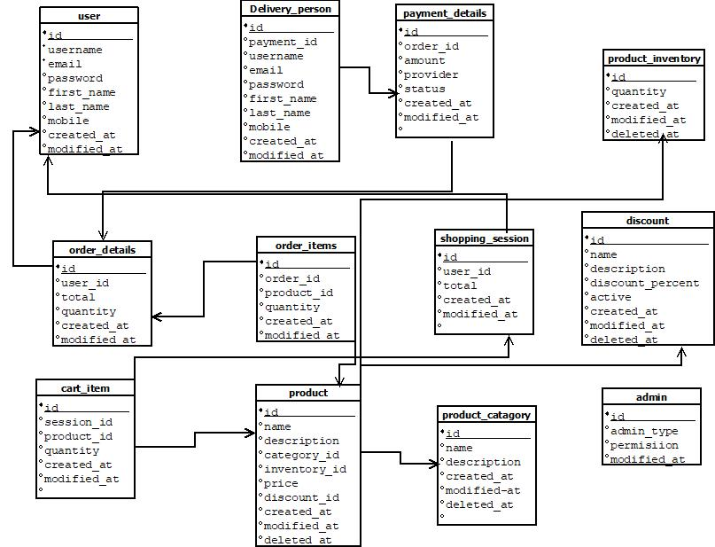

**9.Table Creation:**

**1.** create sequence type_T_ID_seq start with 1 increment by 1 nocache;

CREATE TABLE type(T_ID NUMBER(10) CONSTRAINT PK_type PRIMARY KEY,username VARCHAR2(25) ,email VARCHAR2(50),password VARCHAR2(20),First_name VARCHAR2(20),Last_name VARCHAR2(50), T_created_at VARCHAR2(50), T_modified_at VARCHAR2(50))

CREATE INDEX type_index ON type(T_ID,username , email, password , first_name , Last_name , T_created_at , T_modified_at );

**2**. create sequence admin_A_ID_seq start with 1 increment by 1 nocache;

CREATE TABLE admin(A_ID NUMBER(10) CONSTRAINT PK_admin PRIMARY KEY, T_created_at VARCHAR2(50), T_modified_at VARCHAR2(50) , permissions VARCHAR2(50))

CREATE INDEX admin_index ON admin(A_ID, T_created_at , T_modified_at , permissions);

**3.**create sequence deliveryperson_D_ID_seq start with 1 increment by 1 nocache;

CREATE TABLE deliveryperson(D_ID NUMBER(10) CONSTRAINT PK_deliveryperson PRIMARY KEY,username VARCHAR2(25) ,email VARCHAR2(50),password VARCHAR2(20),First_name VARCHAR2(20),Last_name VARCHAR2(50), D_created_at VARCHAR2(50), D_modified_at VARCHAR2(50))

CREATE INDEX deliveryperson_index ON deliveryperson(D_ID,username , email, password , first_name , Last_name , D_created_at , D_modified_at );

**4**. create sequence paymentdetails_Pa_ID_seq start with 1 increment by 1 nocache;

CREATE TABLE paymentdetails(Pa_ID NUMBER(10) CONSTRAINT PK_paymentdetails PRIMARY KEY,amount VARCHAR2(50) ,provider VARCHAR2(50) , status VARCHAR2(50) , P_created_at VARCHAR2(50), P_modified_at VARCHAR2(50))

CREATE INDEX paymentdetails_index ON paymentdetails(Pa_ID, amount , provider , status , P_created_at , P_modified_at);

**5.** create sequence orderdetails_O_ID_seq start with 1 increment by 1 nocache;

CREATE TABLE orderdetails(O_ID NUMBER(10) CONSTRAINT PK_orderdetails PRIMARY KEY,quantity VARCHAR2(50) , total VARCHAR2(50) , O_created_at VARCHAR2(50), O_modified_at VARCHAR2(50)) CREATE INDEX orderdetails_index ON orderdetails(O_ID, quantity , total , O_created_at , O_modified_at);

**6.** create sequence user_U_ID_seq start with 1 increment by 1 nocache;

CREATE TABLE user1(U_ID NUMBER(10) CONSTRAINT PK_user PRIMARY KEY,username VARCHAR2(25) ,email VARCHAR2(50),password VARCHAR2(20),mobile VARCHAR2(20),First_name VARCHAR2(20),Last_name VARCHAR2(50), U_created_at VARCHAR2(50), U_modified_at VARCHAR2(50))

CREATE INDEX user1_index ON user1(U_ID, username , email, password , mobile , first_name , Last_name , U_created_at , U_modified_at );

**7**. create sequence orderitems_Oi_ID_seq start with 1 increment by 1 nocache;

CREATE TABLE orderitems(Oi_ID NUMBER(10) CONSTRAINT PK_orderitems PRIMARY KEY, oi_quantity VARCHAR2(50), Oi_created_at VARCHAR2(50), Oi_modified_at VARCHAR2(50))

CREATE INDEX orderitems_index ON orderitems(Oi_ID,oi_quantity , Oi_created_at , Oi_modified_at );

**8.** create sequence payment_P_ID_seq start with 1 increment by 1 nocache;

CREATE TABLE payment(P_ID NUMBER(10) CONSTRAINT PK_payment PRIMARY KEY, type VARCHAR2(50), provider VARCHAR2(50), account_no VARCHAR2(50) , expiry VARCHAR(50))

CREATE INDEX payment_index ON payment(P_ID , type , provider , account_no , expiry );

**9.** create sequence address_Ad_ID_seq start with 1 increment by 1 nocache;

CREATE TABLE address(Ad_ID NUMBER(10) CONSTRAINT PK_address PRIMARY KEY,address_line1 VARCHAR2(25) ,address_line2 VARCHAR2(50),city VARCHAR2(20),mobile VARCHAR2(20))

CREATE INDEX address_index ON address(Ad_ID,address_line1 , Address_line2 , city , mobile );

**10.** create sequence shoppingsession_S_ID_seq start with 1 increment by 1 nocache;

CREATE TABLE shoppingsession(S_ID NUMBER(10) CONSTRAINT PK_shoppingsession PRIMARY KEY, total VARCHAR2(50), S_created_at VARCHAR2(50), S_modified_at VARCHAR2(50))

CREATE INDEX shoppingsession_index ON shoppingsession(S_ID, total , S_created_at , S_modified_at );

**11.** create sequence cart_C_ID_seq start with 1 increment by 1 nocache;

CREATE TABLE cart(C_ID NUMBER(10) CONSTRAINT PK_cart PRIMARY KEY, quantity VARCHAR2(50), C_created_at VARCHAR2(50), C_modified_at VARCHAR2(50))

CREATE INDEX cart_index ON cart(C_ID, quantity , C_created_at , C_modified_at );

**12.** create sequence catagory_Ca_ID_seq start with 1 increment by 1 nocache;

CREATE TABLE catagory(Ca_ID NUMBER(10) CONSTRAINT PK_catagory PRIMARY KEY,name VARCHAR2(25) , Ca_created_at VARCHAR2(50), Ca_modified_at VARCHAR2(50) ,Ca_deleted_at VARCHAR2(50), describe VARCHAR2(50))

CREATE INDEX catagory_index ON catagory(Ca_ID, Ca_created_at , Ca_modified_at, name , Ca_deleted_at , describe );

**13.** create sequence product_Pr_ID_seq start with 1 increment by 1 nocache;

CREATE TABLE product(Pr_ID NUMBER(10) CONSTRAINT PK_product PRIMARY KEY,name VARCHAR2(25) , description VARCHAR2(25) , price VARCHAR2(25) ,Pr_created_at VARCHAR2(50), Pr_modified_at VARCHAR2(50) ,Pr_deleted_at VARCHAR2(50))

CREATE INDEX product_index ON product(Pr_ID , name , description , price , Pr_created_at , Pr_modified_at , Pr_deleted_at );

**14**.create sequence inventory_I_ID_seq start with 1 increment by 1 nocache;

CREATE TABLE inventory(I_ID NUMBER(10) CONSTRAINT PK_inventory PRIMARY KEY,quantity VARCHAR2(50) , I_created_at VARCHAR2(50), I_modified_at VARCHAR2(50), I_deleted_at VARCHAR2(50))

CREATE INDEX inventory_index ON inventory(I_ID, quantity , I_created_at , I_modified_at , I_deleted_at);

**15**.create sequence discount_Di_ID_seq start with 1 increment by 1 nocache;

CREATE TABLE discount(Di_ID NUMBER(10) CONSTRAINT PK_discount PRIMARY KEY,name VARCHAR2(50) , desc1 VARCHAR2(50) , parcent VARCHAR2(50) , active VARCHAR2(50) ,Di_created_at VARCHAR2(50), Di_modified_at VARCHAR2(50), Di_deleted_at VARCHAR2(50))

CREATE INDEX discount_index ON discount(Di_ID, name , desc1 , parcent , active , Di_created_at , Di_modified_at, Di_deleted_at );

**10.Data insertion:**

**1.**

INSERT INTO type(T_ID, username , email, password , first_name , Last_name , T_created_at , T_modified_at) VALUES(type_T_ID_seq.NEXTVAL,'oishorjo','ishorju2018@gmail.com','12345', 'oisho' , 'agnes' , '1.5.21' ,'2.6.21');

INSERT INTO type(T_ID, username , email, password , first_name , Last_name , T_created_at , T_modified_at) VALUES(type_T_ID_seq.NEXTVAL,'Dip','dip@gmail.com','1234567', 'naimul' , 'Dip' , '3.5.21' ,'4.6.21');

INSERT INTO type(T_ID, username , email, password , first_name , Last_name , T_created_at , T_modified_at) VALUES(type_T_ID_seq.NEXTVAL,'somudro','somudro@gmail.com','23456', 'arafee' , 'Somudro' , '8.5.21' ,'6.6.21');

INSERT INTO type(T_ID, username , email, password , first_name , Last_name , T_created_at , T_modified_at) VALUES(type_T_ID_seq.NEXTVAL,'shuvo','shuvo@gmail.com',' 17545', 'shuvo' , 'rahman' , '4.5.21' ,'5.6.21');

INSERT INTO type(T_ID, username , email, password , first_name , Last_name , T_created_at , T_modified_at) VALUES(type_T_ID_seq.NEXTVAL,'iqbal','iqbal@gmail.com','67545', 'shuvo' , 'rahman' , '14.5.21' ,'15.6.21');

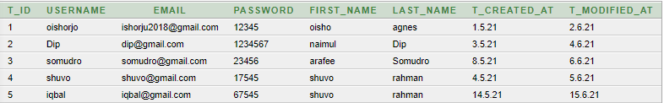

**2.**

INSERT INTO admin(A_ID, T_created_at , T_modified_at , permissions) VALUES(admin_A_ID_seq.NEXTVAL,'2.5.21', '1.5.21' ,'Yes');

INSERT INTO admin(A_ID, T_created_at , T_modified_at , permissions) VALUES(admin_A_ID_seq.NEXTVAL,'7.5.21', '6.5.21' ,'Yes');

INSERT INTO admin(A_ID, T_created_at , T_modified_at , permissions) VALUES(admin_A_ID_seq.NEXTVAL,'7.5.21', '9.5.21' ,'Yes');

INSERT INTO admin(A_ID, T_created_at , T_modified_at , permissions) VALUES(admin_A_ID_seq.NEXTVAL,'12.5.21', '11.5.21' ,'Yes');

INSERT INTO admin(A_ID, T_created_at , T_modified_at , permissions) VALUES(admin_A_ID_seq.NEXTVAL,'11.5.21', '12.5.21' ,'Yes');

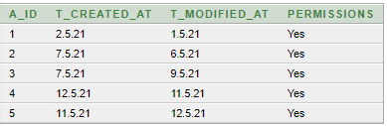

**3.**

INSERT INTO deliveryperson(D_ID, username , email, password , first_name , Last_name , D_created_at , D_modified_at) VALUES(deliveryperson_D_ID_seq.NEXTVAL,'merina','merina@gmail.com','1234567', 'tanjin' , 'Shithi' , '1.5.21' ,'2.6.21');

INSERT INTO deliveryperson(D_ID, username , email, password , first_name , Last_name , D_created_at , D_modified_at) VALUES(deliveryperson_D_ID_seq.NEXTVAL,'Bappy','bappy@gmail.com','123456789', 'Supantha' , 'Bappy' , '14.5.21' ,'7.6.21');

INSERT INTO deliveryperson(D_ID, username , email, password , first_name , Last_name , D_created_at , D_modified_at) VALUES(deliveryperson_D_ID_seq.NEXTVAL,'Sadat','sadat@gmail.com','1234678', 'Jubayer' , 'Sadat' , '8.5.21' ,'21.6.21');

INSERT INTO deliveryperson(D_ID, username , email, password , first_name , Last_name , D_created_at , D_modified_at) VALUES(deliveryperson_D_ID_seq.NEXTVAL,'karim','karim@gmail.com','1237878', 'sheikh' , 'karim' , '8.5.21' ,'21.6.21');

INSERT INTO deliveryperson(D_ID, username , email, password , first_name , Last_name , D_created_at , D_modified_at) VALUES(deliveryperson_D_ID_seq.NEXTVAL,'Rahim','rarim@gmail.com','12356778', 'Islam' , 'Rarim' , '18.5.21' ,'22.6.21');

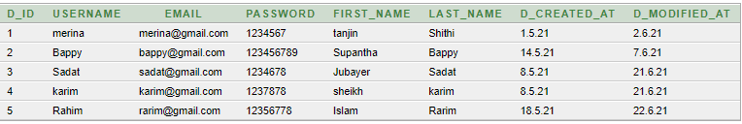

**4.**

INSERT INTO paymentdetails(Pa_ID, amount , provider , status , P_created_at , P_modified_at

) VALUES(paymentdetails_Pa_ID_seq.NEXTVAL,'1000', 'Hasan' ,'Complete' , '2.5.21', '1.5.21' );

INSERT INTO paymentdetails(Pa_ID, amount , provider , status , P_created_at , P_modified_at

) VALUES(paymentdetails_Pa_ID_seq.NEXTVAL,'5000', 'Faridul' ,'Complete' , '8.2.21', '4.5.21' );

INSERT INTO paymentdetails(Pa_ID, amount , provider , status , P_created_at , P_modified_at

) VALUES(paymentdetails_Pa_ID_seq.NEXTVAL,'7000', 'Sadia' ,'Complete' , '6.5.21', '10.5.21' );

INSERT INTO paymentdetails(Pa_ID, amount , provider , status , P_created_at , P_modified_at

) VALUES(paymentdetails_Pa_ID_seq.NEXTVAL,'8000', 'Zohra' ,'Complete' , '16.5.21', '17.5.21' );

INSERT INTO paymentdetails(Pa_ID, amount , provider , status , P_created_at , P_modified_at

) VALUES(paymentdetails_Pa_ID_seq.NEXTVAL,'5000', 'tanjin' ,'Complete' , '6.5.21', '7.5.21' );

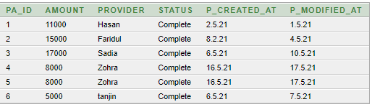

**5.**

INSERT INTO orderdetails(O_ID, quantity , total , O_created_at , O_modified_at) VALUES(orderdetails_O_ID_seq.NEXTVAL,'10' , '10' ,'2.5.21', '1.5.21' );

INSERT INTO orderdetails(O_ID, quantity , total , O_created_at , O_modified_at) VALUES(orderdetails_O_ID_seq.NEXTVAL,'20' , '20' ,'4.5.21', '8.5.21' );

INSERT INTO orderdetails(O_ID, quantity , total , O_created_at , O_modified_at) VALUES(orderdetails_O_ID_seq.NEXTVAL,'40' , '40' ,'8.5.21', '9.5.21' );

INSERT INTO orderdetails(O_ID, quantity , total , O_created_at , O_modified_at) VALUES(orderdetails_O_ID_seq.NEXTVAL,'60' , '60' ,'18.5.21', '19.5.21' );

INSERT INTO orderdetails(O_ID, quantity , total , O_created_at , O_modified_at) VALUES(orderdetails_O_ID_seq.NEXTVAL,'90' , '90' ,'18.5.21', '19.5.21' );

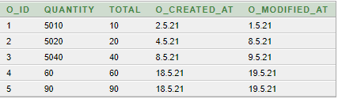

**6**.

INSERT INTO user1(U_ID, username , email, password , mobile , first_name , Last_name , U_created_at , U_modified_at) VALUES(user_U_ID_seq.NEXTVAL,'fahim','fahim@gmail.com','1234567','01873678676', 'Islam' , 'Fahim' , '1.5.21' ,'2.6.21');

INSERT INTO user1(U_ID, username , email, password , mobile , first_name , Last_name , U_created_at , U_modified_at) VALUES(user_U_ID_seq.NEXTVAL,'fahim','fahim@gmail.com','1234567','01873678676', 'Islam' , 'Fahim' , '1.5.21' ,'2.6.21');

INSERT INTO user1(U_ID, username , email, password , mobile , first_name , Last_name , U_created_at , U_modified_at) VALUES(user_U_ID_seq.NEXTVAL,'mahadi','mahadi@gmail.com','12356767','01876765632', 'Haque' , 'Mahadi' , '9.5.21' ,'11.6.21');

INSERT INTO user1(U_ID, username , email, password , mobile , first_name , Last_name , U_created_at , U_modified_at) VALUES(user_U_ID_seq.NEXTVAL,'Ishmam','ishmam@gmail.com','123569090','0171267893', 'Haque' , 'Ishmam' , '9.3.21' ,'11.3.21');

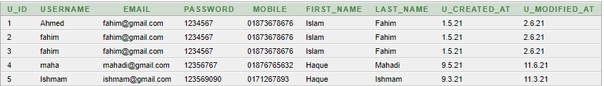

**7.**

INSERT INTO orderitems(Oi_ID,oi_quantity , Oi_created_at , Oi_modified_at ) VALUES(orderitems_Oi_ID_seq.NEXTVAL,'10' ,'2.5.21', '1.5.21');

INSERT INTO orderitems(Oi_ID,oi_quantity , Oi_created_at , Oi_modified_at ) VALUES(orderitems_Oi_ID_seq.NEXTVAL,'22' ,'9.5.21', '11.5.21');

INSERT INTO orderitems(Oi_ID,oi_quantity , Oi_created_at , Oi_modified_at ) VALUES(orderitems_Oi_ID_seq.NEXTVAL,'20' ,'9.4.21', '11.4.21');

INSERT INTO orderitems(Oi_ID,oi_quantity , Oi_created_at , Oi_modified_at ) VALUES(orderitems_Oi_ID_seq.NEXTVAL,'10' ,'19.4.21', '20.4.21');

INSERT INTO orderitems(Oi_ID,oi_quantity , Oi_created_at , Oi_modified_at ) VALUES(orderitems_Oi_ID_seq.NEXTVAL,'80' ,'11.4.21', '12.4.21');



**8.**

INSERT INTO payment(P_ID , type , provider , account_no , expiry ) VALUES(payment_P_ID_seq.NEXTVAL,'cash' ,'Hasan', '123','1.5.21');

INSERT INTO payment(P_ID , type , provider , account_no , expiry ) VALUES(payment_P_ID_seq.NEXTVAL,'credit' ,'Iqbal', '124','12.5.21');

INSERT INTO payment(P_ID , type , provider , account_no , expiry ) VALUES(payment_P_ID_seq.NEXTVAL,'cash' ,'Rahman', '126','1.6.21');

INSERT INTO payment(P_ID , type , provider , account_no , expiry ) VALUES(payment_P_ID_seq.NEXTVAL,'cash' ,'Sam', '120','11.6.21');

INSERT INTO payment(P_ID , type , provider , account_no , expiry ) VALUES(payment_P_ID_seq.NEXTVAL,'cash' ,'masud', '121','20.6.21');

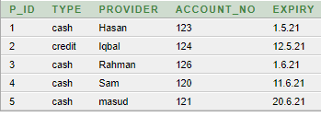

**9.**

INSERT INTO address(Ad_ID, address_line1 , Address_line2 , city , mobile ) VALUES(address_Ad_ID_seq.NEXTVAL,'Shahinbag','mirpur','Dhaka', '01765789876' );

INSERT INTO address(Ad_ID, address_line1 , Address_line2 , city , mobile ) VALUES(address_Ad_ID_seq.NEXTVAL,'East Rajabazar','Farmgate','Dhaka', '01765788766' );

INSERT INTO address(Ad_ID, address_line1 , Address_line2 , city , mobile ) VALUES(address_Ad_ID_seq.NEXTVAL,'Lake park','Gulshan','Dhaka', '01967893765' );

INSERT INTO address(Ad_ID, address_line1 , Address_line2 , city , mobile ) VALUES(address_Ad_ID_seq.NEXTVAL,'Residential area','Bashundhara','Dhaka', '01978903657' );

INSERT INTO address(Ad_ID, address_line1 , Address_line2 , city , mobile ) VALUES(address_Ad_ID_seq.NEXTVAL,'Kuratoli','Bisshoroad','Dhaka', '01789026546' );

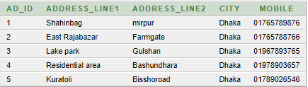

**10.**

INSERT INTO shoppingsession(S_ID, total , S_created_at , S_modified_at) VALUES(shoppingsession_S_ID_seq.NEXTVAL,'10' ,'2.5.21', '1.5.21');

INSERT INTO shoppingsession(S_ID, total , S_created_at , S_modified_at) VALUES(shoppingsession_S_ID_seq.NEXTVAL,'20' ,'21.5.21', '22.5.21');

INSERT INTO shoppingsession(S_ID, total , S_created_at , S_modified_at) VALUES(shoppingsession_S_ID_seq.NEXTVAL,'30' ,'12.5.21', '13.5.21');

INSERT INTO shoppingsession(S_ID, total , S_created_at , S_modified_at) VALUES(shoppingsession_S_ID_seq.NEXTVAL,'50' ,'12.5.21', '13.5.21');

INSERT INTO shoppingsession(S_ID, total , S_created_at , S_modified_at) VALUES(shoppingsession_S_ID_seq.NEXTVAL,'90' ,'2.5.21', '3.5.21');

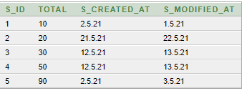

**11.**

INSERT INTO cart(C_ID, quantity , C_created_at , C_modified_at) VALUES(cart_C_ID_seq.NEXTVAL,'5' ,'2.5.21', '1.5.21');

INSERT INTO cart(C_ID, quantity , C_created_at , C_modified_at) VALUES(cart_C_ID_seq.NEXTVAL,'15' ,'12.5.21', '13.5.21');

INSERT INTO cart(C_ID, quantity , C_created_at , C_modified_at) VALUES(cart_C_ID_seq.NEXTVAL,'12' ,'21.5.21', '22.5.21');

INSERT INTO cart(C_ID, quantity , C_created_at , C_modified_at) VALUES(cart_C_ID_seq.NEXTVAL,'20' ,'11.5.21', '12.5.21');

INSERT INTO cart(C_ID, quantity , C_created_at , C_modified_at) VALUES(cart_C_ID_seq.NEXTVAL,'50' ,'1.5.21', '2.5.21');

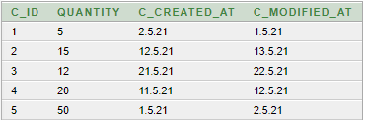

**12.**

INSERT INTO catagory(Ca_ID, Ca_created_at , Ca_modified_at, name , Ca_deleted_at , describe ) VALUES(catagory_Ca_ID_seq.NEXTVAL, '1.5.21' ,'2.6.21' , ' food' , '5.6.21' , 'rice -bread_butter');

INSERT INTO catagory(Ca_ID, Ca_created_at , Ca_modified_at, name , Ca_deleted_at , describe ) VALUES(catagory_Ca_ID_seq.NEXTVAL, '4.5.21' ,'5.6.21' , ' Stationary' , '6.6.21' , 'book -Pencil_pen');

INSERT INTO catagory(Ca_ID, Ca_created_at , Ca_modified_at, name , Ca_deleted_at , describe ) VALUES(catagory_Ca_ID_seq.NEXTVAL, '8.5.21' ,'9.6.21' , ' Clothes' , '10.6.21' , 'dress -shirt_pant');

INSERT INTO catagory(Ca_ID, Ca_created_at , Ca_modified_at, name , Ca_deleted_at , describe ) VALUES(catagory_Ca_ID_seq.NEXTVAL, '11.5.21' ,'9.6.21' , ' Bags' , '11.6.21' , 'ladiesbag -bagpack');

INSERT INTO catagory(Ca_ID, Ca_created_at , Ca_modified_at, name , Ca_deleted_at , describe ) VALUES(catagory_Ca_ID_seq.NEXTVAL, '12.5.21' ,'9.6.21' , ' grocery' , '10.6.21' , 'sugar-flour’);

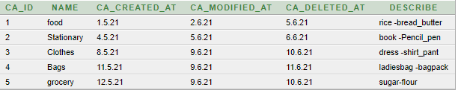

**13.**

INSERT INTO product(Pr_ID , name , description , price , Pr_created_at , Pr_modified_at , Pr_deleted_at ) VALUES(product_Pr_ID_seq.NEXTVAL, 'Food' , 'rice_bread' , '200' , '4.5.21' ,'5.6.21', '6.6.21');

INSERT INTO product(Pr_ID , name , description , price , Pr_created_at , Pr_modified_at , Pr_deleted_at ) VALUES(product_Pr_ID_seq.NEXTVAL, 'Clothes' , 'dress_shirt' , '2000' , '4.6.21' ,'15.6.21', '16.6.21');

INSERT INTO product(Pr_ID , name , description , price , Pr_created_at , Pr_modified_at , Pr_deleted_at ) VALUES(product_Pr_ID_seq.NEXTVAL, 'Stationary' , 'Book_pencil' , '200' , '14.5.21' ,'15.5.21', '16.5.21');

INSERT INTO product(Pr_ID , name , description , price , Pr_created_at , Pr_modified_at , Pr_deleted_at ) VALUES(product_Pr_ID_seq.NEXTVAL, 'grocery' , 'flour_sugar' , '300' , '14.5.21' ,'5.5.21', '6.5.21');

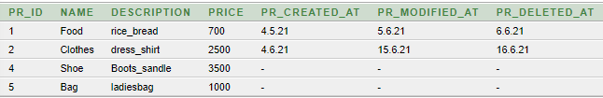

**14.**

INSERT INTO inventory(I_ID, quantity , I_created_at , I_modified_at , I_deleted_at) VALUES(inventory_I_ID_seq.NEXTVAL,'10' ,'2.5.21', '11.5.21' , '12.5.21' );

INSERT INTO inventory(I_ID, quantity , I_created_at , I_modified_at , I_deleted_at) VALUES(inventory_I_ID_seq.NEXTVAL,'20' ,'12.5.21', '13.5.21' , '14.5.21' );

INSERT INTO inventory(I_ID, quantity , I_created_at , I_modified_at , I_deleted_at) VALUES(inventory_I_ID_seq.NEXTVAL,'30' ,'21.5.21', '22.5.21' , '23.5.21' );

INSERT INTO inventory(I_ID, quantity , I_created_at , I_modified_at , I_deleted_at) VALUES(inventory_I_ID_seq.NEXTVAL,'25' ,'11.5.21', '12.5.21' , '13.5.21' );

INSERT INTO inventory(I_ID, quantity , I_created_at , I_modified_at , I_deleted_at) VALUES(inventory_I_ID_seq.NEXTVAL,'50' ,'5.5.21', '6.5.21' , '8.5.21' );

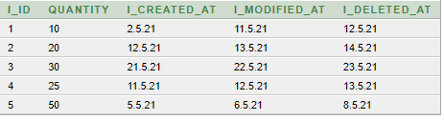

**15.**

INSERT INTO discount(Di_ID, name , desc1 , parcent , active , Di_created_at , Di_modified_at, Di_deleted_at ) VALUES(discount_Di_ID_seq.NEXTVAL,'Flash_sale' ,'sale_on_food', '20%' , 'yes' ,'13.5.21' , '14.5.21' ,'13.8.21');

INSERT INTO discount(Di_ID, name , desc1 , parcent , active , Di_created_at , Di_modified_at, Di_deleted_at ) VALUES(discount_Di_ID_seq.NEXTVAL,'Eid_sale' ,'sale_on_Dress', '10%' , 'No' ,'10.5.21' , '14.5.21' ,'13.6.21');

INSERT INTO discount(Di_ID, name , desc1 , parcent , active , Di_created_at , Di_modified_at, Di_deleted_at ) VALUES(discount_Di_ID_seq.NEXTVAL,'Summer_sale' ,'sale_on_food', '10%' , 'yes' ,'13.4.21' , '14.4.21' ,'13.7.21');

INSERT INTO discount(Di_ID, name , desc1 , parcent , active , Di_created_at , Di_modified_at, Di_deleted_at ) VALUES(discount_Di_ID_seq.NEXTVAL,'winter_sale' ,'sale_on_clothes', '10%' , 'No' ,'13.12.20' , '14.12.20' ,'13.1.21');

INSERT INTO discount(Di_ID, name , desc1 , parcent , active , Di_created_at , Di_modified_at, Di_deleted_at ) VALUES(discount_Di_ID_seq.NEXTVAL,'lockdown_sale' ,'sale_on_food', '10%' , 'No' ,'1.4.21' , '11.4.21' ,'13.5.21');

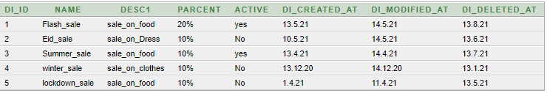

**11.Query writing:**

**SQL**

**Single Row:**

SELECT UPPER (first_name), INITCAP (last_name) FROM type WHERE rownum < 5;

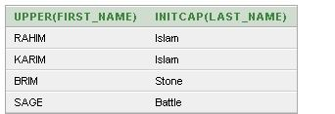

SELECT CONCAT (u_first_name, u_last_name) FROM user_customer WHERE rownum < 5;

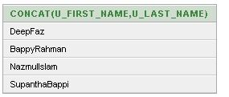

SELECT SUBSTR (first_name, 1, 5), INSTR (first_name, 'a') FROM type WHERE rownum < 5;

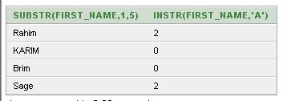

**Group Function:**

SELECT COUNT(*) Count FROM type;



SELECT COUNT (*) FROM type WHERE first_name = 'Rahim';



SELECT first_name, last_name FROM type ORDER BY first_name DESC;

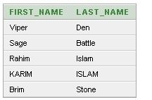

**Sub Query:**

SELECT a_id FROM admin WHERE t_id IN (1, 3) ORDER BY a_permissions;

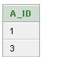

SELECT a_id FROM admin WHERE t_id NOT IN (SELECT t_id FROM type WHERE t_email = '12345') ORDER BY a_permissions;

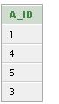

DELETE FROM admin WHERE t_id=ANY( SELECT t_id FROM type WHERE t_email='12345');

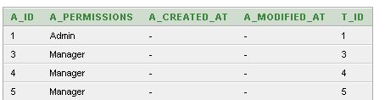

**Joining:**

SELECT A_ID, A_PERMISSIONS FROM Admin, type WHERE admin.a_id = type.T_Id;

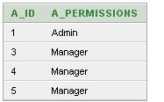

SELECT A_ID, A_PERMISSIONS FROM ADMIN INNER JOIN type ON admin.a_id= type.t_id;

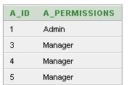

SELECT A_ID, A_PERMISSIONS FROM ADMIN FULL JOIN TYPE ON admin.a_id = type.T_Id;

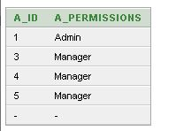

**View:**

CREATE VIEW DELIVERY_VIEW AS SELECT d_first_name, d_last_name FROM delivery;

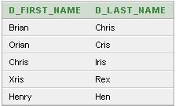

UPDATE DELIVERY_VIEW SET D_FIRST_NAME = 'Bappa' WHERE d_last_name = 'Rex';

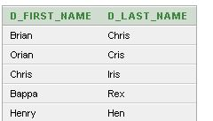

DELETE FROM delivery_VIEW WHERE d_first_name = 'Bappa';

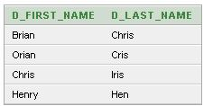

**Synonym:**

CREATE SYNONYM deliveries FOR d_email.delivery;

CREATE SYNONYM types FOR t_email.type;

CREATE SYNONYM user_customers FOR u_email.user_customer;

**Pl/Sql**

**Functions**

**1.**

CREATE OR REPLACE FUNCTION totalproduct

RETURN number AS

total number(2) := 0;

BEGIN

SELECT count(*) into total

FROM product;

RETURN total;

END;

DECLARE

c number(2);

BEGIN

c := totalproduct();

dbms_output.put_line('Total no. of product: ' || c);

END;

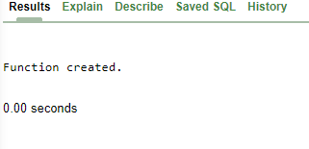

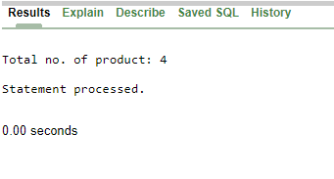

**2.**

CREATE OR REPLACE FUNCTION totaldiscount

RETURN number AS

total number(2) := 0;

BEGIN

SELECT count(*) into total

FROM discount;

RETURN total;

END;

DECLARE

c number(2);

BEGIN

c := totaldiscount();

dbms_output.put_line('Total no. of discount: ' || c);

END;



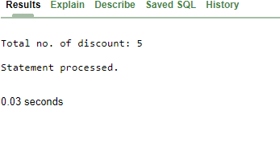

**3.**

CREATE OR REPLACE FUNCTION totaladmin

RETURN number AS

total number(2) := 0;

BEGIN

SELECT count(*) into total

FROM admin;

RETURN total;

END;

DECLARE

c number(2);

BEGIN

c := totaladmin();

dbms_output.put_line('Total no. of admin: ' || c);

END;



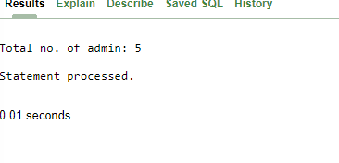

**2.Procedure**

**1.**

create or replace procedure "Main"

(U_Id IN NUMBER,

email IN VARCHAR2)

is

begin

insert into user1 values(U_Id,email);

end;

/

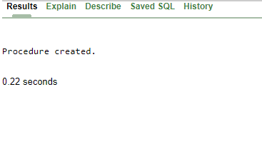

**2.**

CREATE OR REPLACE PROCEDURE updateuser1(

p_U_Id IN user1.U_ID%TYPE,

p_username IN user1.USERNAME%TYPE)

IS

BEGIN

UPDATE user1 SET USERNAME = p_username where U_ID = p_u_id;

COMMIT;

END;

/



BEGIN

updateuser1(4,'manir');

END;

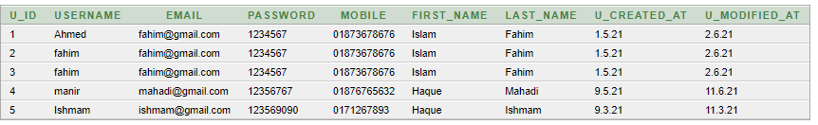

**3**.

Drop procedure updateuser1

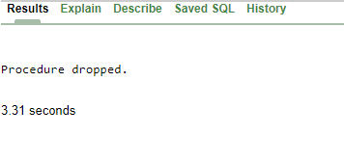

**Record:**

**1.**

DECLARE

user1_rec user1%rowtype;

BEGIN

SELECT * into user1_rec

FROM user1

WHERE U_Id = 4;

dbms_output.put_line('user ID: ' || user1_rec.U_Id);

dbms_output.put_line('user firstName: ' || user1_rec.first_name);

dbms_output.put_line('user Email: ' || user1_rec.email);

dbms_output.put_line('user mobile: ' || user1_rec.mobile);

END;

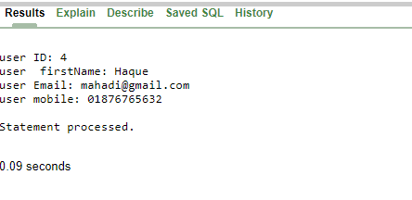

**2.**

DECLARE

CURSOR user1_cur is

SELECT U_Id , first_name , last_name

FROM user1;

user1_rec user1_cur%rowtype;

BEGIN

OPEN user1_cur;

LOOP

FETCH user1_cur into user1_rec;

EXIT WHEN user1_cur%notfound;

DBMS_OUTPUT.put_line(user1_rec.U_Id || ' ' || user1_rec.first_name);

END LOOP;

END;

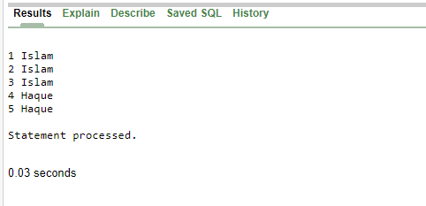

**3.**

DECLARE

discount_rec discount%rowtype;

BEGIN

SELECT * into discount_rec

FROM discount

WHERE Di_Id = 5;

dbms_output.put_line('discount ID: ' || discount_rec.Di_Id);

dbms_output.put_line('discount Name: ' || discount_rec.name);

dbms_output.put_line('discount desc1: ' || discount_rec.desc1);

END;

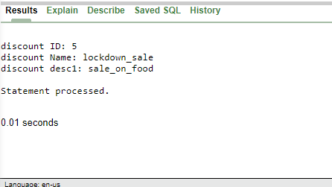

**Cursor**

**1.**

DECLARE

user1_rec user1%rowtype;

BEGIN

SELECT * into user1_rec

FROM user1

WHERE U_Id = 4;

dbms_output.put_line('user ID: ' || user1_rec.U_Id);

dbms_output.put_line('user firstName: ' || user1_rec.first_name);

dbms_output.put_line('user Email: ' || user1_rec.email);

dbms_output.put_line('user mobile: ' || user1_rec.mobile);

END;

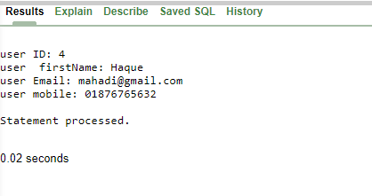

**2.**

DECLARE

total_count number(30);

BEGIN

--updating a row

UPDATE user1

SET username= 'Ahmed' where U_Id = 1;

-- result in boolean, true returned if no rows affected

IF sql%notfound THEN

dbms_output.put_line('no subjects fetched');

-- result in boolean, true returned if any rows affected

ELSIF sql%found THEN

-- count the number of rows affected rows affected

total_count := sql%rowcount;

dbms_output.put_line( total_count || ' name updated ');

END IF;

END;

/

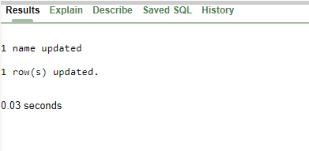

**3.**

DECLARE

-- cursor declaration

CURSOR c2 is

SELECT U_Id , username , email FROM user1;

U_Id user1.U_Id%type;

username user1.username%type;

email user1.email%type;

BEGIN

-- opening a cursor

OPEN c2;

LOOP

-- fetching values from cursor

FETCH c2 into U_Id , username , email;

EXIT WHEN c2%notfound;

-- printing in console

dbms_output.put_line('Code is: ' || U_Id || ' ' || 'name is: ' || username || ' email is: ' || email);

END LOOP;

CLOSE c2;

END;

/

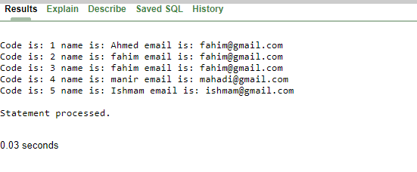

**Trigger**

**1.**

DECLARE

total_rows number(2);

BEGIN

UPDATE paymentdetails

SET amount = amount + 5000;

IF sql%notfound THEN

dbms_output.put_line('no amount updated');

ELSIF sql%found THEN

total_rows := sql%rowcount;

dbms_output.put_line( total_rows || ' amount updated ');

END IF;

END;

/

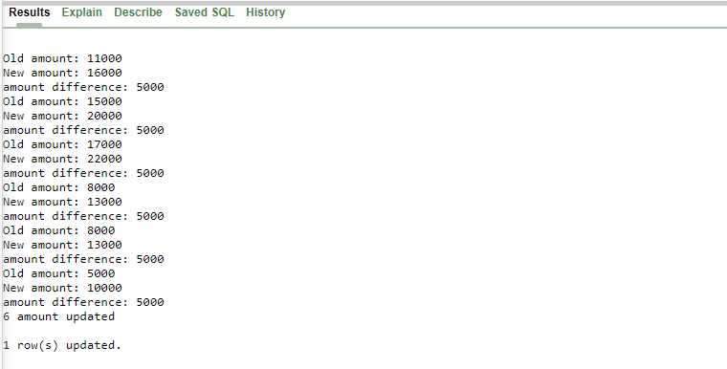

**2.**

CREATE OR REPLACE TRIGGER display_orderdetails_changes

BEFORE DELETE OR INSERT OR UPDATE ON orderdetails

FOR EACH ROW

WHEN (NEW.O_ID > 0)

DECLARE

quantity_diff number;

BEGIN

quantity_diff := :NEW.quantity - :OLD.quantity;

dbms_output.put_line('Old quantity: ' || :OLD.quantity);

dbms_output.put_line('New quantity: ' || :NEW.quantity);

dbms_output.put_line('quantity difference: ' || quantity_diff);

END;

/

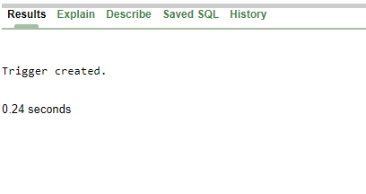

**3.**

DECLARE

total_rows number(2);

BEGIN

UPDATE orderdetails

SET quantity = quantity + 5000;

IF sql%notfound THEN

dbms_output.put_line('no quantity updated');

ELSIF sql%found THEN

total_rows := sql%rowcount;

dbms_output.put_line( total_rows || ' quantity updated ');

END IF;

END;

/

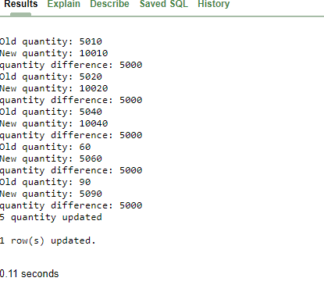

**Package**

**1.**

CREATE OR REPLACE PACKAGE c_package AS

-- Adds a product

PROCEDURE addproduct(c_id product.Pr_id%type,

c_name product.Name%type,

c_description product.description%type,

c_price product.price%type);

-- Removes a product

PROCEDURE delproduct(c_id product.Pr_id%TYPE);

--Lists all product

PROCEDURE listproduct;

END c_package;

/

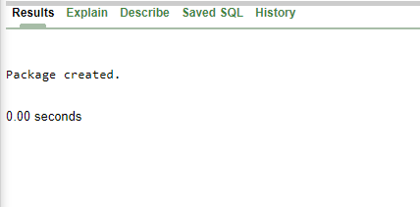

**2.**

CREATE OR REPLACE PACKAGE BODY c_package AS

PROCEDURE addproduct(c_id product.pr_id%type,

c_name product.Name%type,

c_description product.description%type,

c_price product.price%type)

IS

BEGIN

INSERT INTO product (Pr_id , name , description , price)

VALUES(c_id, c_name, c_description, c_price);

END addproduct;

PROCEDURE delproduct(c_id product.Pr_id%type) IS

BEGIN

DELETE FROM product

WHERE Pr_id = c_id;

END delproduct;

PROCEDURE listproduct IS

CURSOR c_product is

SELECT name FROM product;

TYPE c_list is TABLE OF product.Name%type;

name_list c_list := c_list();

counter integer :=0;

BEGIN

FOR n IN c_product LOOP

counter := counter +1;

name_list.extend;

name_list(counter) := n.name;

dbms_output.put_line('Product(' ||counter|| ')'||name_list(counter));

END LOOP;

END listproduct;

END c_package;

/

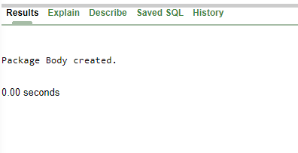

**3.**

DECLARE

code product.Pr_id%type:= 3;

BEGIN

c_package.addproduct(6, 'Shoe','Boots_sandle', '3500');

c_package.addproduct(7, 'Bag', 'ladiesbag', '1000');

c_package.listproduct;

c_package.delproduct(code);

c_package.listproduct;

END;

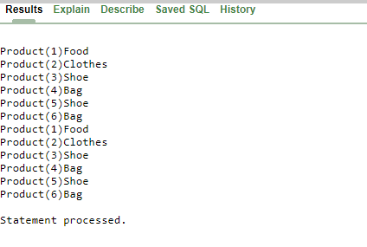

1. **Conclusion:** In this project report we are trying to design a shop management system database where user can buy a product from a sales man. There is an admin who has control each and every procedure of this shop management system. we created table for our shop management system by using normalization (up to 3NF). In this shop management system here lot of tables like customer, employee, product, admin, payment table created. Then we insert our data in this table after that we are writing query in our oracle software. In future we want to develop our database so that we can use our shop management system in larger scale.